Nokia Withings registration

Made 06.08.2018.

To use the API of Nokia Withings, you need to generate API credentials.

1. Go to the Nokia Withings page <https://account.health.nokia.com/connectionuser/account_create>, enter you data and click Create.

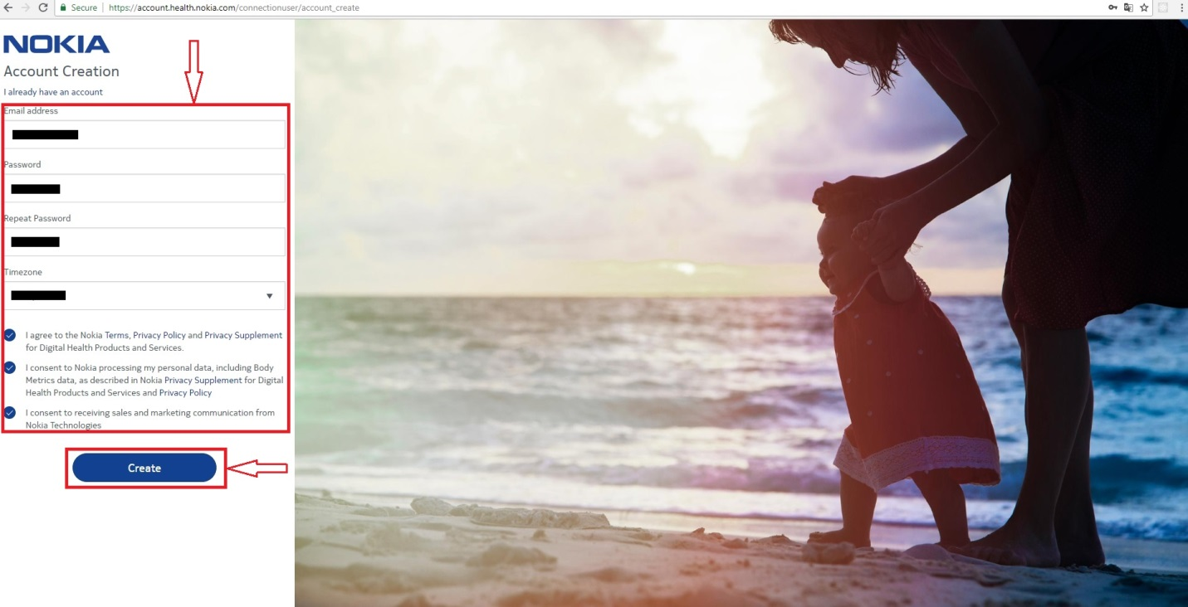

1. Enter information about you and click Next.

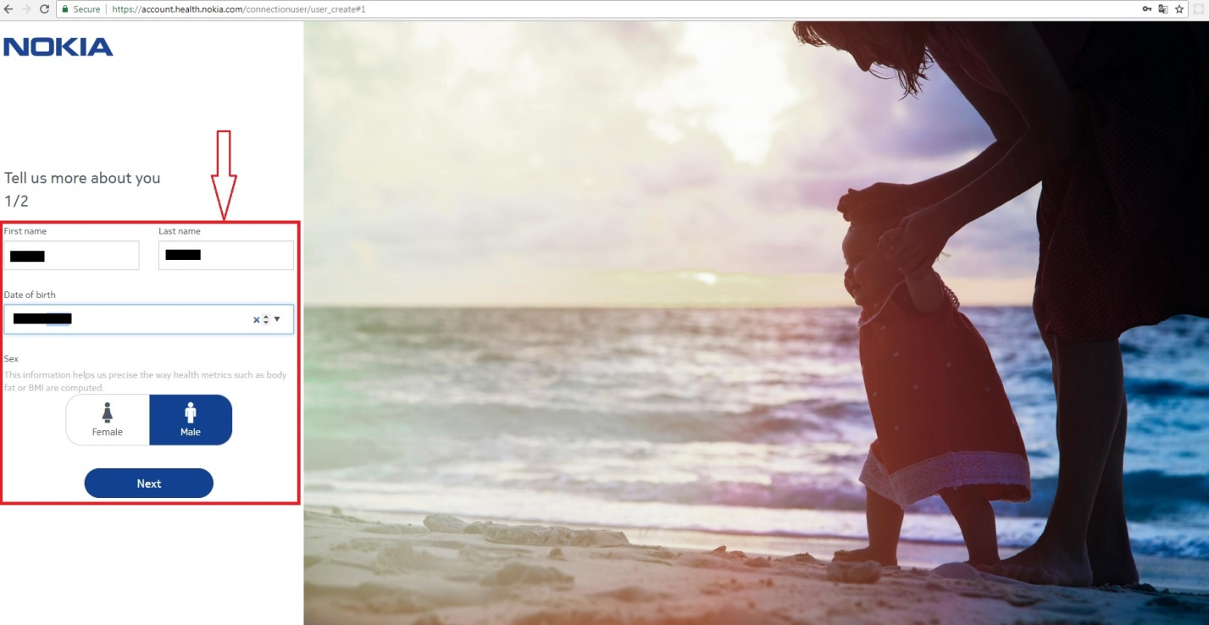

1. Enter more information about you and click Next.

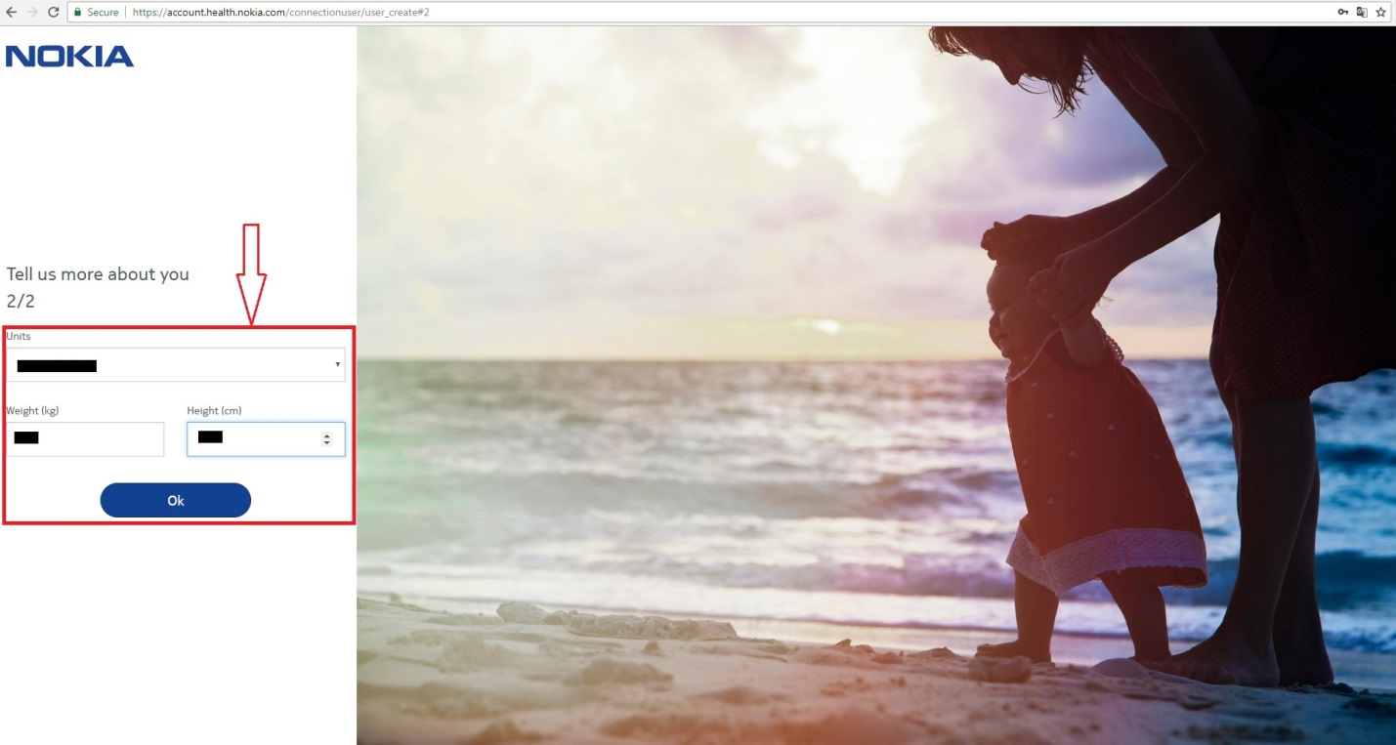

1. You can start using The web version of Nokia Withings.

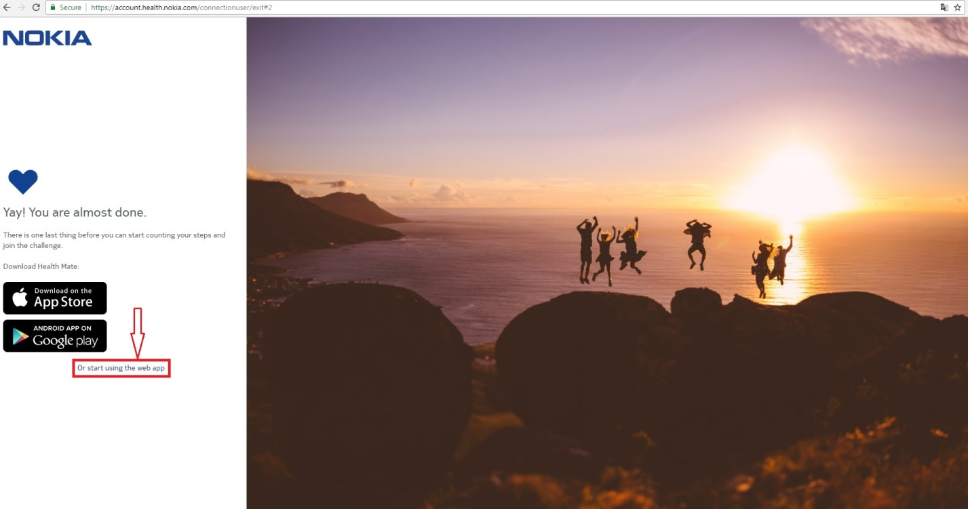

1. When you have the Nokia Within account, you can register your own App.   
   Go to the page <https://account.health.nokia.com/partner/add_oauth2>, enter data about your App and click Register.

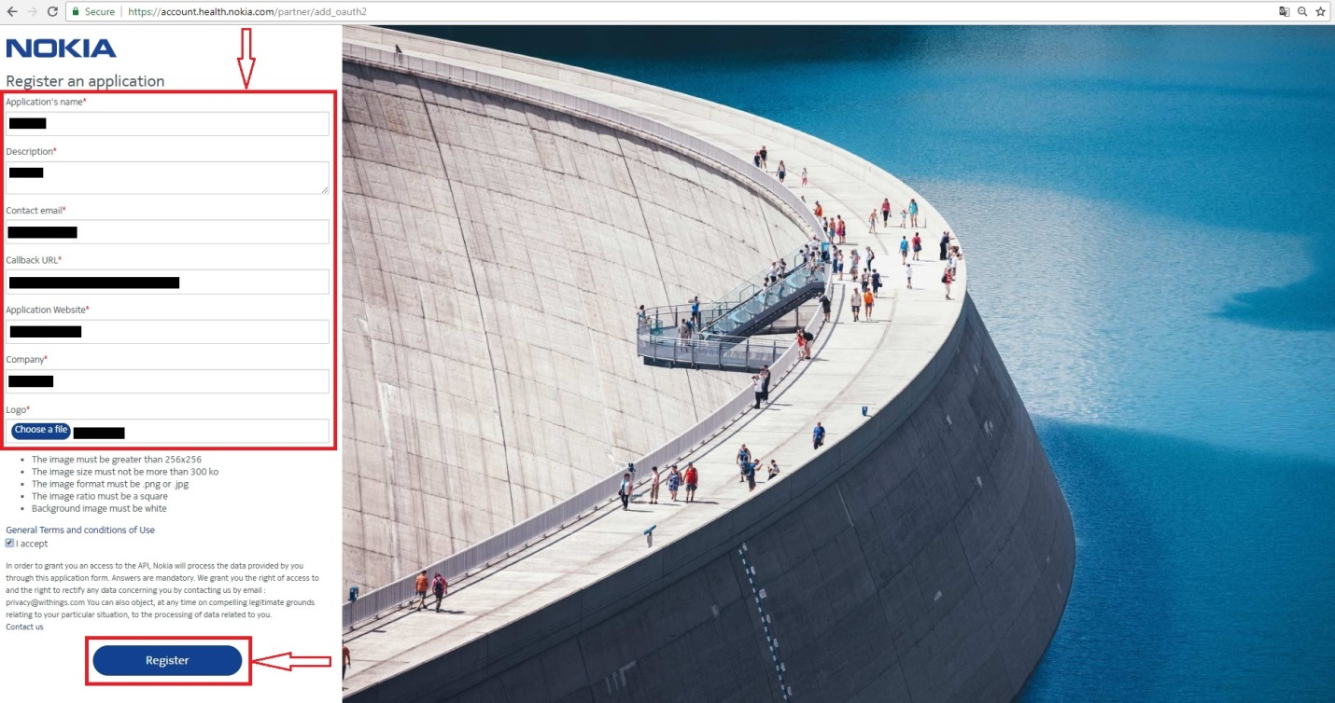

6. Get your API credentials for using the Nokia Withings API.

